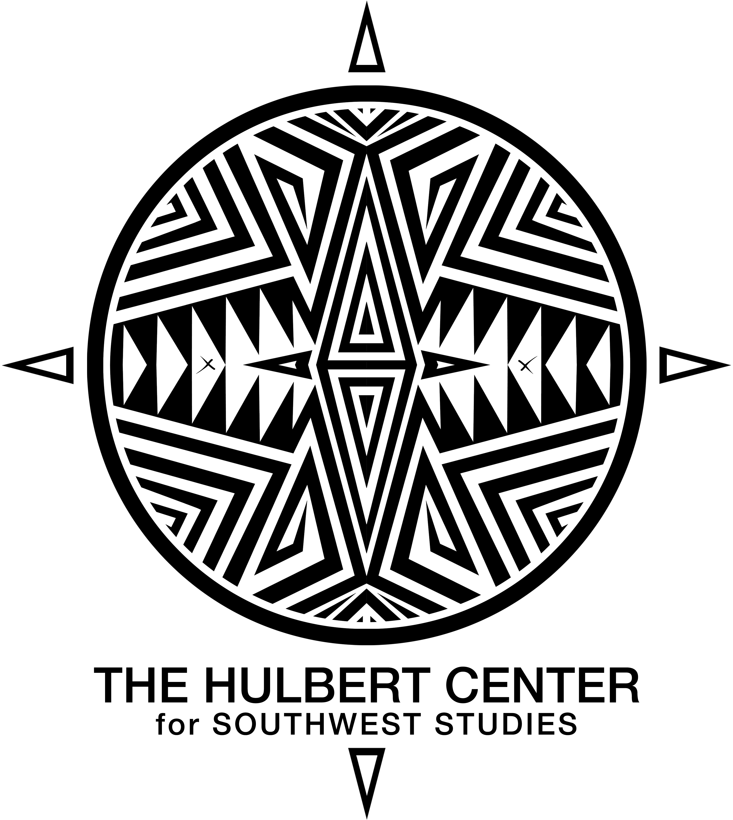

**FACULTY AFFILIATE SPEAKER REQUEST PROPOSAL FORM**

**NAME: (**Include your name, home department and contact information)

**PROPOSED SPEAKER** (Please include institutional information, contact information, and a short bio or CV):

**EVENT DETAILS:** (Please describe the expected speaker engagements during their visit:

class visit, student workshop, evening lecture)

**ITEMIZED BUDGET:** (Please submit a detailed budget, that includes honorarium in accordance with the Hulbert Center Speaker Honoraria Schedule, see below)

* Honoraria
* Round Trip Flights to COS Airport (Estimate)
* Number of Nights for Lodging (at $175/ night)
* Number of Dinners and number of attendees (at $500 maximum / dinner)
* Additional Anticipated Costs

**STATEMENT OF SOUTHWEST STUDIES IMPACT AND RELAVENCE:**

(What are your goals with the event? How will this visitor contribute to mission of the Southwest Studies academic program and the Hulbert Center of Southwest Studies? Why do you think it is appropriate for The Hulbert Center for Southwest Studies to support the event?)

**SOUTHWEST STUDIES HONORARIA SCHEDULE**

1) Aficionados Luncheon: **$500.00**

2) Class convergence: **$500.00**

3) Workshop: **$500.00**

4) Evening Lecture: **$1,000.00**

**ADDITIONAL NOTES FOR CONSIDERATION:**

* The Hulbert Center will fund 3 - 4 visiting speakers proposed by faculty affiliates per academic year
* Faculty affiliates can apply to bring a speaker each year
* If awarded a programming fellowship, the faculty affiliate must assume on campus responsibility for their visitor

**SOUTHWEST STUDIES ACADEMIC PROGRAM MISSION:**

The mission of the Southwest Studies program is to provide the finest liberal arts education, using a critical regional studies approach, centered on the Greater Southwest and the U.S.-Mexico borderlands. Spanning Texas, New Mexico, Arizona, Nevada and parts of Colorado, Utah, California, Oklahoma and northern Mexico, the diversity of the Southwest’s landscapes and cultures are rivaled by few other regions on Earth. Our program’s interdisciplinary approach to peoples, places, and landscapes provides a model for study applicable to any region. Using the insights of traditional disciplines in combination with critical approaches to learning, we provide a holistic view of the Southwest that educates students to observe places, learn from and with the region’s peoples, and to imagine potential outcomes.

**THE HULBERT CENTER FOR SOUTHWEST STUDIES MISSION:**

Established in 1981 by Professor Joseph Gordon, the Hulbert Center for Southwest Studies was the first regional interdisciplinary program in the nation. Its original mission was to create curriculum with Southwest content at Colorado College, nurture a community of scholars who could serve the region through teaching and publishing and create community outreach programs educating the community at-large about the Southwest.