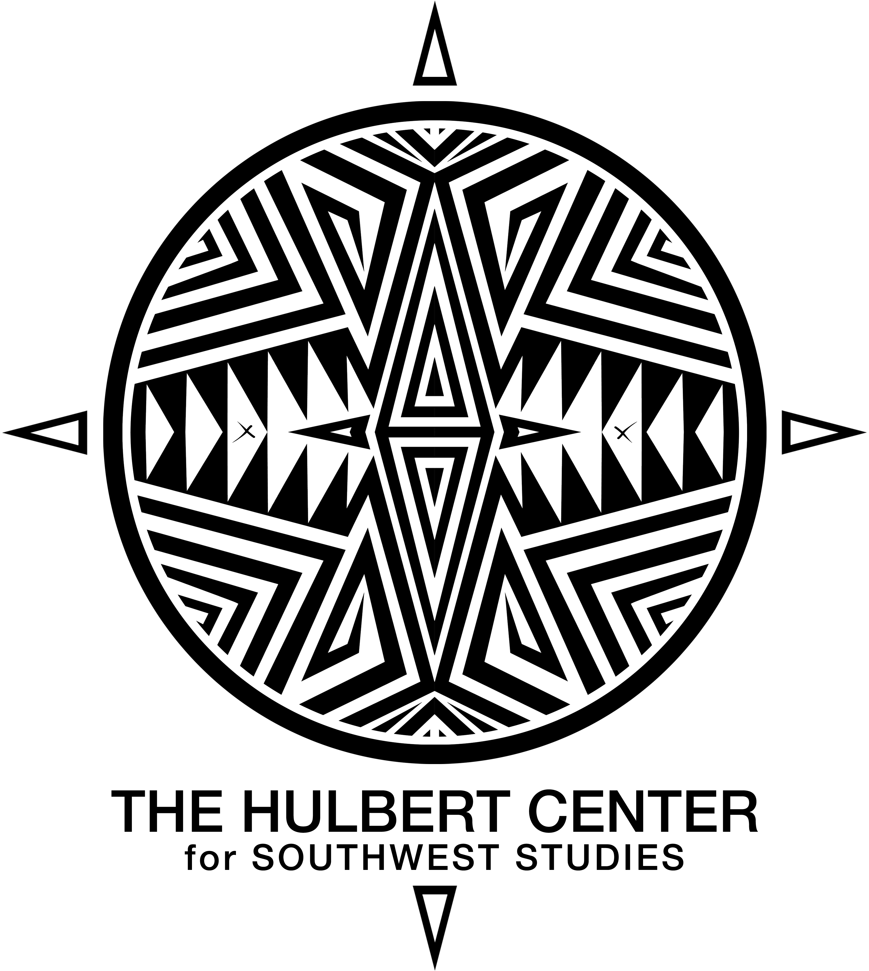

**FACULTY AFFILIATE FIELD TRIP FUND REQUEST FORM**

**INSTRUCTOR NAME: (**Include your name, home department and contact information)

**COURSE NAME AND DESCRIPTION**:

**ITEMIZED BUDGET FOR THE FIELD EXPERIENCE:**

**TOTAL REQUESTED FROM SOUTHWEST STUDIES: (UP TO $2000)**

**SHORT STATEMENT OF SOUTHWEST STUDIES IMPACT AND RELAVENCE:**

(Is the course currently cross-listed or if not, do you believe it is appropriate for crosslisting? How does this course contribute to the mission of the Southwest Studies academic program and the Hulbert Center of Southwest Studies? Why do you think it is appropriate for The Hulbert Center for Southwest Studies to support the field trip for this course?)

**SOUTHWEST STUDIES ACADEMIC PROGRAM MISSION:**

The mission of the Southwest Studies program is to provide the finest liberal arts education, using a critical regional studies approach, centered on the Greater Southwest and the U.S.-Mexico borderlands. Spanning Texas, New Mexico, Arizona, Nevada and parts of Colorado, Utah, California, Oklahoma and northern Mexico, the diversity of the Southwest’s landscapes and cultures are rivaled by few other regions on Earth. Our program’s interdisciplinary approach to peoples, places, and landscapes provides a model for study applicable to any region. Using the insights of traditional disciplines in combination with critical approaches to learning, we provide a holistic view of the Southwest that educates students to observe places, learn from and with the region’s peoples, and to imagine potential outcomes.

**THE HULBERT CENTER FOR SOUTHWEST STUDIES MISSION:**

Established in 1981 by Professor Joseph Gordon, the Hulbert Center for Southwest Studies was the first regional interdisciplinary program in the nation. Its original mission was to create curriculum with Southwest content at Colorado College, nurture a community of scholars who could serve the region through teaching and publishing and create community outreach programs educating the community at-large about the Southwest.